**Step 1: Acknowledge Pre-installed Appliance**

* This lab continues from **Lab 1** where the Storage Gateway appliance was installed.
* Confirm that the appliance is already installed and running

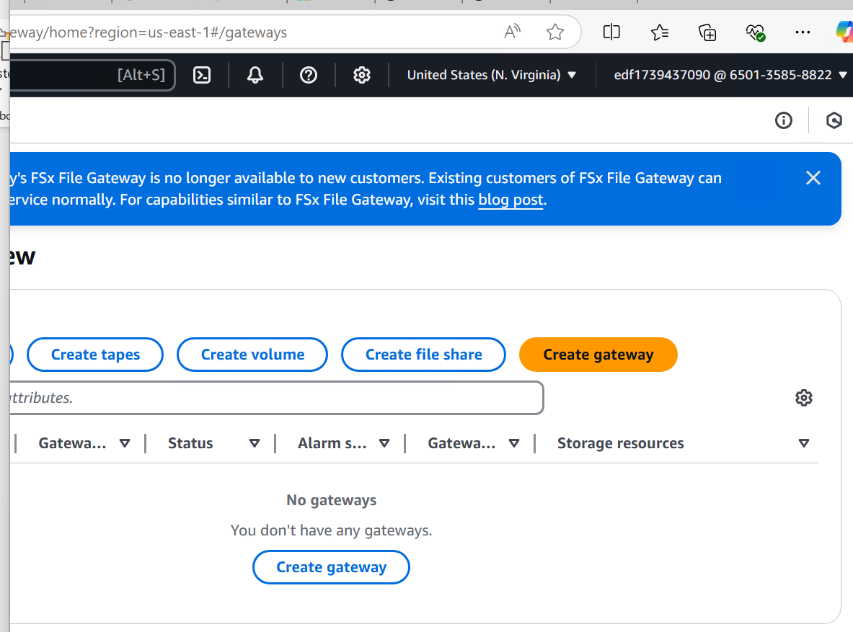

**Note: we have already installed the appliance**

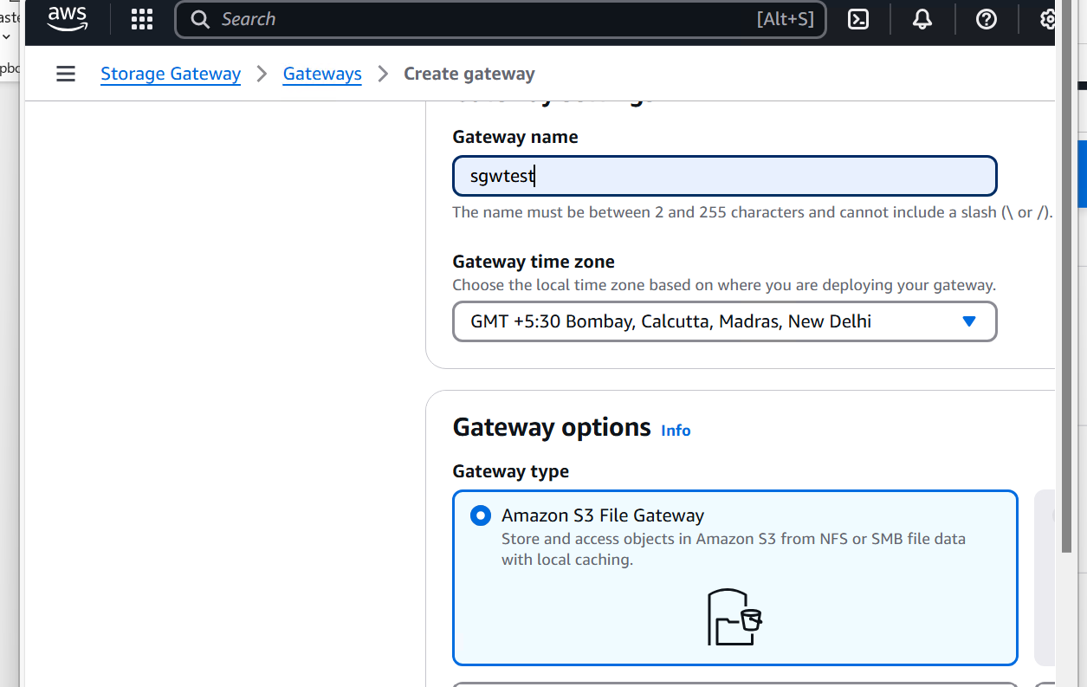

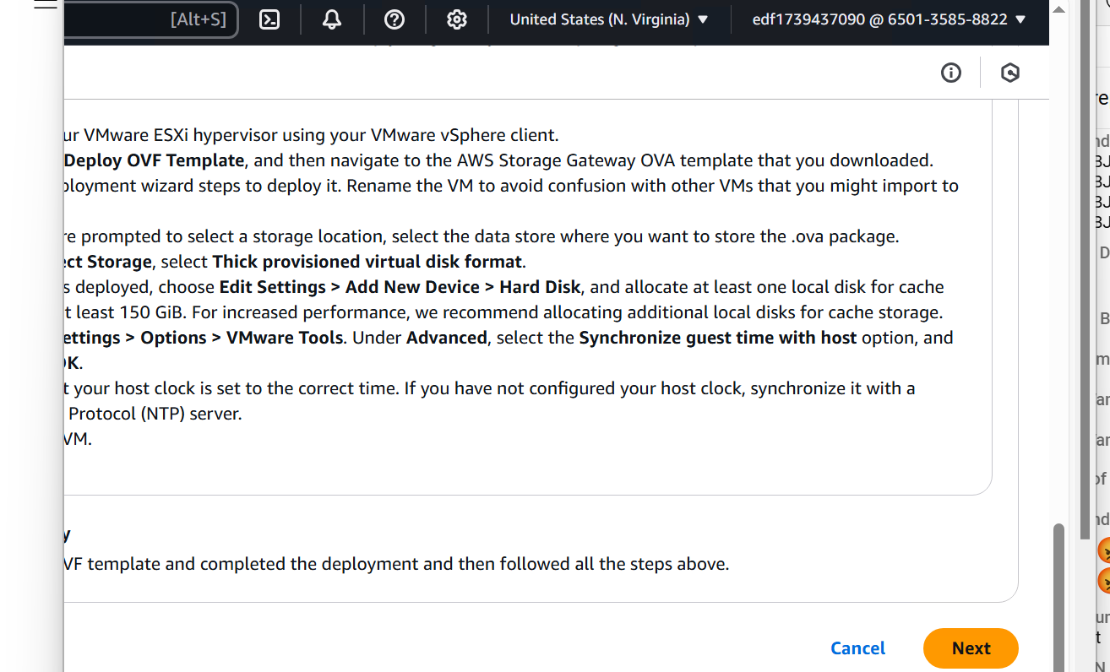

**Step 2: Retrieve Appliance IP Address**

* Open the **VMware vSphere Client** or the **web console** of the appliance.
* Locate the **IP address** assigned to the Storage Gateway appliance.

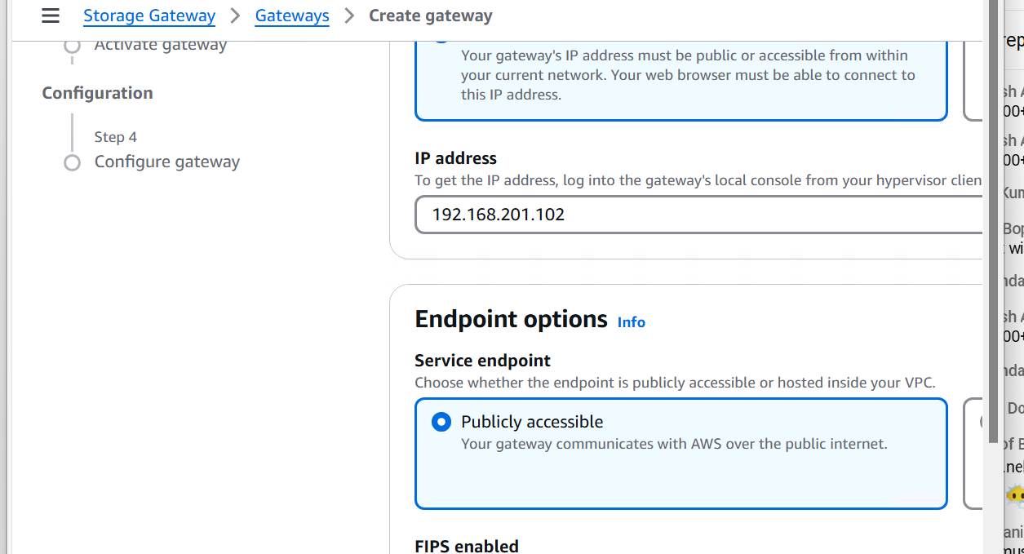

**Step 3: Provide Appliance IP Address in AWS Console**

* Log in to the **AWS Management Console**.
* Navigate to **Storage Gateway**.
* Enter the **retrieved IP address** in the appropriate field.

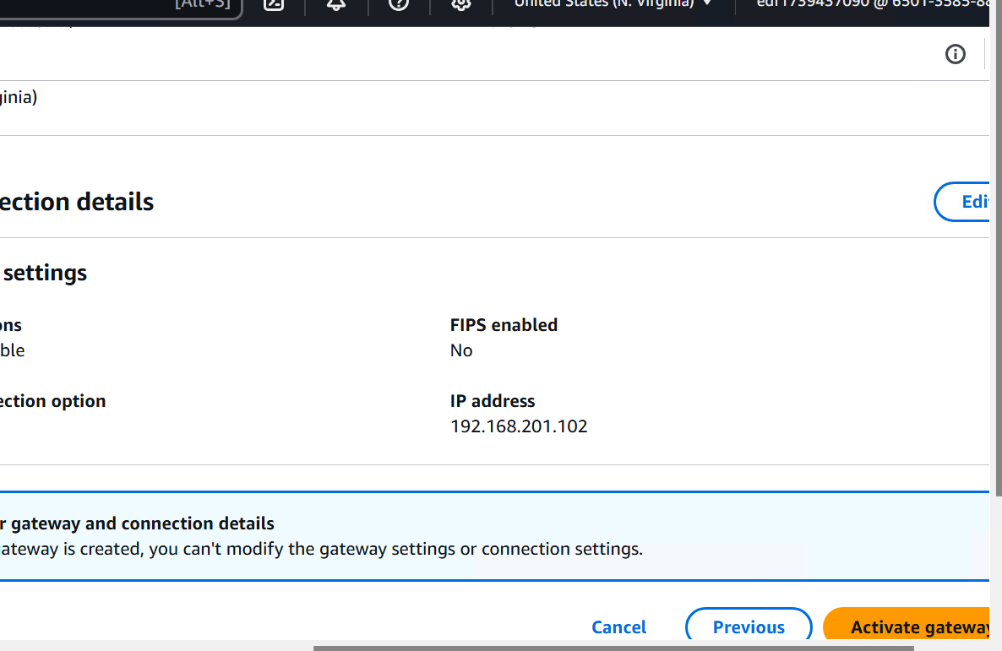

**Step 4: Activate the Gateway**

* Click on **Activate Gateway** in the AWS Console.
* Wait for the activation to complete successfully.